**Problem Statement**

How might we help professional exhibition lovers in Shanghai to sift through various exhibitions so that they can easily choose the exhibitions that meet their specific requirements on theme/time/location, etc.?

**Plan**



**Result**

It was observed that all participants turned to the search box on the top-right corner of the home page.

Figure1



They had to scroll down and compare the date of exhibitions manually since no sorting method was provided on the search result page, as showed in figure 2.

Figure 2

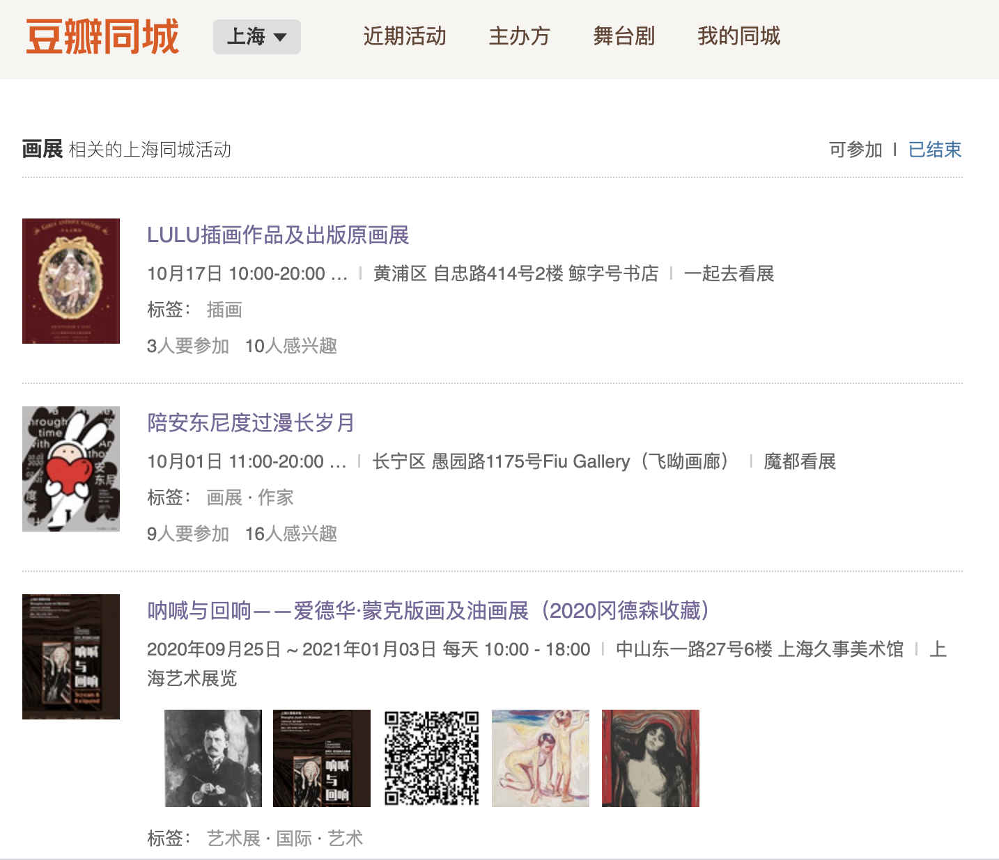

However, none of them find the answer there, since only one exhibition opened after 20 October can be found in the result page. As a result, they tried out different methods， as showed in following table.

|  |  |  |  |  |  |
| --- | --- | --- | --- | --- | --- |
| Participant | A | B | C | D | E |
| Step 1 | Search for “画展” in search box, select manually, and find the first proper exhibition from the list (149s) | Search for “画展” in search box, select manually, and find the first proper exhibition from the list (110s) | Search for “画展” in search box, select manually, and find the first proper exhibition from the list (132s) | Search for “画展” in search box, select manually, and find the first proper exhibition from the list (116s) | Search for “画展” in search box, select manually, and find the first proper exhibition from the list (137s) |
| Step 2 | Return to the homepage and click on “展览” (13s) | Return to the homepage and click on “其他活动” (10s) | Search for “画” in search box, and manually find out the second proper exhibition (34s) | Repeat the same operation, stuck there and announce that he cannot complete the task (27s) | Return to the home page and search for “油画”, and manually find out the second proper exhibition (38s) |
| Step3 | Set search criteria as Figure 3 and then find the second result (56s) | Set search criteria as Figure 4 and then find the result (193s)  NOTE: She claimed that it was difficult to recognize which result is about painting | N/A | N/A | N/A |
| Time spent (second) | 218 | 313 | 166 | 143 (failed) | 175 |

Figure 3



Figure 4



In summary, the test reflects two main problems on Douban: Firstly, the categorization of exhibition is not clear enough (because the user cannot get the full result by merely using the search function, and it is difficult to identify the theme of an exhibition). Secondly, the sorting method within the exhibition list page is unreasonable (because it still takes the user a great amount of time to find the exhibition they want).